**Week 5:** Create an xml for the bookstore. Validate the same using both DTD and XSD.

**Programs:**

**Lab.dtd**

<?xml version="1.0" encoding="UTF-8"?>

<!ELEMENT books (book*)>

<!ELEMENT book (title, author, isbn, publisher, edition, price)>

<!ELEMENT title (#PCDATA)>

<!ELEMENT author (#PCDATA)>

<!ELEMENT isbn (#PCDATA)>

<!ELEMENT publisher (#PCDATA)>

<!ELEMENT edition (#PCDATA)>

<!ELEMENT price (#PCDATA)>

**Bookstab.xml**

<?xml version="1.0" encoding="UTF-8"?>

<!DOCTYPE bookstab SYSTEM "lab.dtd">

<?xml-stylesheet type="text/xsl" href="books.xsl"?>

<books>

<book>

<title>Programming the World Wide Web</title>

<author>Robert W. Sebesta</author>

<isbn>1234-5678</isbn>

<publisher>Tata McGraw-Hill</publisher>

<edition>Seventh</edition>

<price>300</price>

</book>

<book>

<title>Web Technologies</title>

<author>Uttam K Roy</author>

<isbn>2345-1234</isbn>

<publisher>Oxford University Press</publisher>

<edition>First</edition>

<price>350</price>

</book>

<book>

<title>The Complete Reference PHP</title>

<author>Steven Holzner</author>

<isbn>4567-8970</isbn>

<publisher>Tata McGraw-Hill</publisher>

<edition>Second</edition>

<price>500</price>

</book>

<book>

<title>Java Script</title>

<author>D Flanagan</author>

<isbn>1234-9876</isbn>

<publisher>Tata</publisher>

<edition>Second</edition>

<price>350</price>

</book>

<book>

<title>Web Programming, Building Internet Applications , 2nd edition , Wiley</title>

<author>Chris Bates</author>

<isbn>3456-8976</isbn>

<publisher>Wiley</publisher>

<edition>Second</edition>

<price>240</price>

</book>

</books>

**Output:**

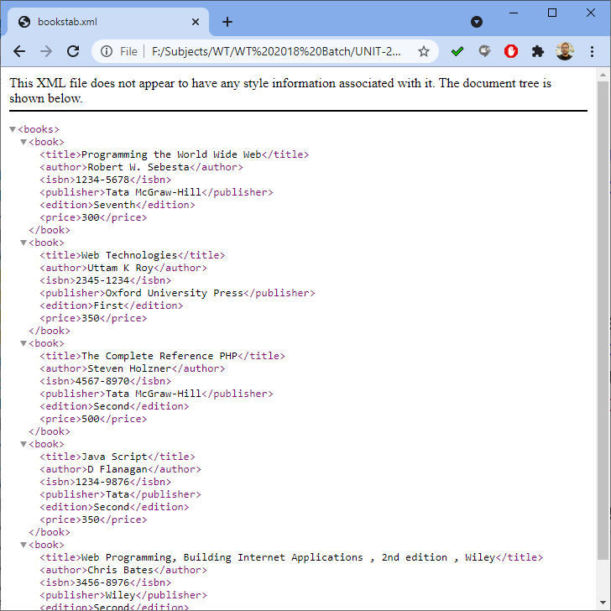

**SchemaEmp.xsd**

<?xml version="1.0" encoding="UTF-8"?>

<xs:schema

xmlns:xs="http://www.w3.org/2001/XMLSchema"

targetNamespace="http://www.eswar.com"

xmlns="http://www.eswar.com"

elementFormDefault="qualified">

<xs:element name="emp">

<xs:complexType>

<xs:sequence>

<xs:element name="empno" type="xs:int"/>

<xs:element name="empname" type="xs:string"/>

<xs:element name="empsal" type="xs:decimal" />

<xs:element name="dept" type="xs:string" fixed="IT"/>

</xs:sequence>

</xs:complexType>

</xs:element>

</xs:schema>

**SchemaEmp.xml**

<?xml version="1.0" encoding="UTF-8"?>

<emp xmlns="http://www.eswar.com"

xmlns:xsi="http://www.w3.org/2001/XMLSchema-instance"

xsi:schemaLocation="http://www.eswar.com SchemaEmp.xsd">

<empno>1201</empno>

<empname>eswar</empname>

<empsal>300.50</empsal>

<dept>IT</dept>

</emp>

**Output:**

